Making Maps for Publication (using QGIS)

Learning outcomes: |  | Tools used:
Designing and producing a publication-ready map in QGIS (p. 1) |  | Symbolising data (p. 2)
Saving/exporting your maps as image files (p. 6) |  | Print composer (p. 3)

1. Introduction
This practical focuses on aspects of map design and symbolisation in QGIS. In particular, it will build upon the skills from the previous practical to look at how QGIS can be used to produce publication quality maps of critical habitats for tiger conservation in India. An example is provided at the back of this handout.

- If you haven’t done so already open My Documents\GIS and create a new folder named prac2
- Download the zip file from https://www.dropbox.com/s/w8qthbdeakfgbae/prac2.zip?dl=0 or bit.ly/1uZUP5o and extract to the prac2 folder as previously.

2. Mapping proposed tiger conservation habitats in India

QGIS has a powerful tool called Print Composer (accessed via Project > New Print Composer) that allows you to create maps. In this part of the practical we show you how to create the Tiger map that’s attached to the end of this handout. We will create the map from scratch and add elements such as north arrow, legends and scale bars. Remember to Save your work as you go.

- Start QGIS by navigating to:
Start > All Programs > QGIS Brighton > QGIS Desktop 2.6.0
- We now need to add our data layers to the map. Click the Add Vector Layer button and then the Browse button. Make sure ESRI Shapefiles (*.shp *.SHP) is selected in the drop down file type menu.
- Select all four Shapefiles (countries.shp, india.shp, reserves_clip.shp and tcu_clip.shp) and click Open, click Open once more.
- The layers will be added in a random order, so rearrange the layers in the layers window with the tcu_clip layer at the top, followed by reserves_clip, india and countries.

You should now have four layers added to the map display. The colours used by default are not particularly helpful so let’s change these to something a little more meaningful.

- Double-click the countries layer (or the colour swab underneath the layer name), select Style (from the left panel) and choose an appropriate colour from the Color swab (perhaps choose the lightest brown)
- Click the General tab and change the Layer name to Other countries, press OK
- Repeat this process to change the colour of the india layer and its name to India
- Change the colour of the reserves_clip layer and change its name to Wildlife reserves
- Change the name of tcu_clip to Tiger conservation units. Click on the Style tab and select Categorized from the top dropdown box. Ensure that LEVEL_ is selected in the Column dropdown box
- Click on New color ramp from the dropdown box next to Color ramp (you might have to scroll down to the bottom of the list). An error might appear saying The selected color ramp is not available, if it does, just click OK. Then a window prompt named Color ramp type will open. Ensure that Gradient is selected and click OK
- We now need to select two colours to create our colour ramp. Change Color 1 to your first colour (perhaps yellow) and repeat for Color 2 (perhaps red). Click OK and, when prompted for a name, enter TCU ramp. Now click OK
- Finally, click Classify to add all the values from the LEVEL_ column field to the symbol window
- Now we need to assign labels, do this according to the table below:

Old label name | New label name
1 | To be surveyed
2 | Low priority
3 | Medium priority
4 | High priority

- When you’re done, select the last value in the list (the one without a label) and choose Delete (this row is added by default and we don’t need it)
- If you wish, choose appropriate colours for each of the labels by clicking on the colour swab under Symbol (changing the symbol of the To be surveyed label might be sensible given that it is not part of the high/medium/low categorisation). Once finished, your view might look something like the screenshot overleaf

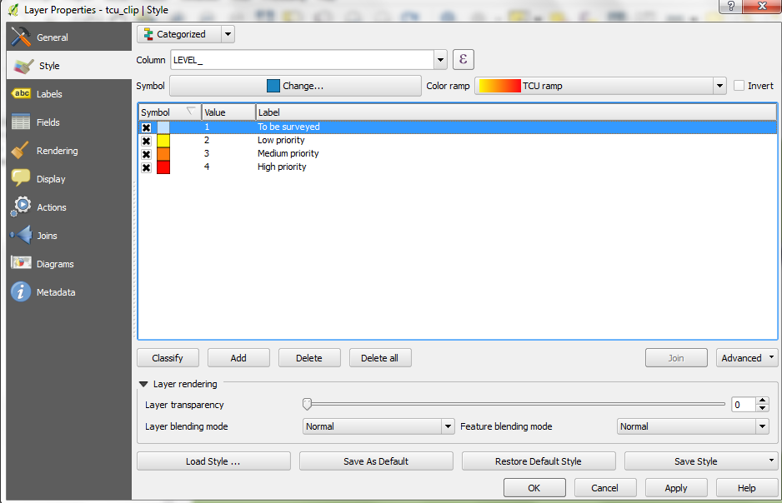

- Finally, click on Value in the header bar to sort the values in descending order (i.e. High priority is at the top of the list)
- Choose OK once you are happy with your labels and colours

Now that we have set up our layers we can start to create our map.

- Go to Project > New Print Composer and the Composer title prompt will open. Enter Practical2 as the title and click OK, the Print Composer window will now open with a blank page
- We need to tell the composer where on the page we would like our map to be positioned. As we a making a map for publication it makes sense to fill the page as much as possible. Click the Add new map button and draw a rectangle on the canvas that fills around a quarter of page
- Alongside the main map view you should see tabs labelled Composition and Item Properties (if you do not see these right-click the top bar and make sure that there is a cross in the checkbox for Composition and Item Properties)
- In the Item Properties tab expand the Position and size properties and change the Width to 140, Height to 120. Change Scale to 20000000 under Main Properties
- Use the Move item content button to position India within the centre of the frame. Note: if the scale changes simply correct the value back to 20000000 and click Update preview to update the display
- Ensure that the checkbox is checked next to Frame

You should notice that the data layers that we have on display in the Print Composer are the same as that in our QGIS project (i.e. the two displays are linked). At the moment we have all of the layers viewable but for this part of the figure we don’t want to display the Tiger conservation units layer (we’ll display this in another map on the same page in a minute).

- Switch windows back to the QGIS project (i.e. not the Print Composer window) and make sure there is not a tick next to the Tiger conservation units layer. Now switch back to the Print Composer window and you’ll see that this layer is now not displayed. Great! If the map in the Print Composer window hasn’t updated, you may need to click Update preview. Your map should display the India, Other countries and Wildlife reserves layers and look something like the screenshot below (ask if you need help)

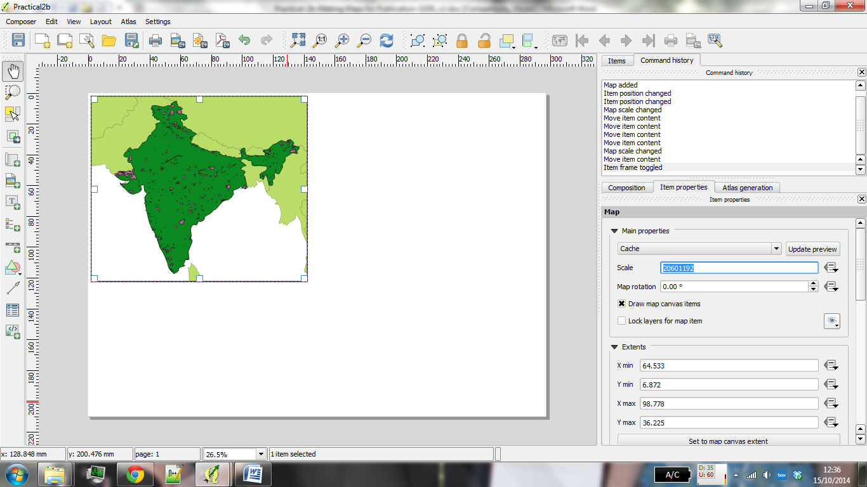
- Before we create another map next to that of the wildlife reserves map we need to tell QGIS to not update the map we’ve created in the Print Composer. To do this check the checkbox next to Lock layers for map items. This will mean that the map will not update as we check layers on/off
- Now is also a good time to save our work, use the Save button to do this.

Right, we can now create an identical map in the top right corner to display our Tiger conservation units layer.

- Go back to the QGIS project window and switch on the Tiger conservation units layer and switch off the Wildlife reserves layer
- Go back to the Print Composer and once again click the Add new map button. Draw a rectangle approximately the same size as the one you already have and a new map will be added to the display
- Once again, change the values for Height, Width and Scale to match our other map and use the Move item content button to position India within the centre of the frame
- Use the Select/Move item 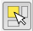 button to position the two maps closely together but with a small gap. If the scale changes, change it back to the correct value
- Ensure that the checkbox is checked next to Frame
- In Item Properties check the checkbox next to Lock layers for map items before moving on

We now need to add a map of the World to the figure to help give viewers some context.

- Leaving just the Other countries layers visible create another map at the bottom of the figure. Play around with moving the Other countries layer into the frame and adjust the scale accordingly until it fills the frame (a scale of 350000000 should just about do it but feel free to choose your own).
- Ensure that the checkbox next to Frame is checked. Your current map should now look something like that below

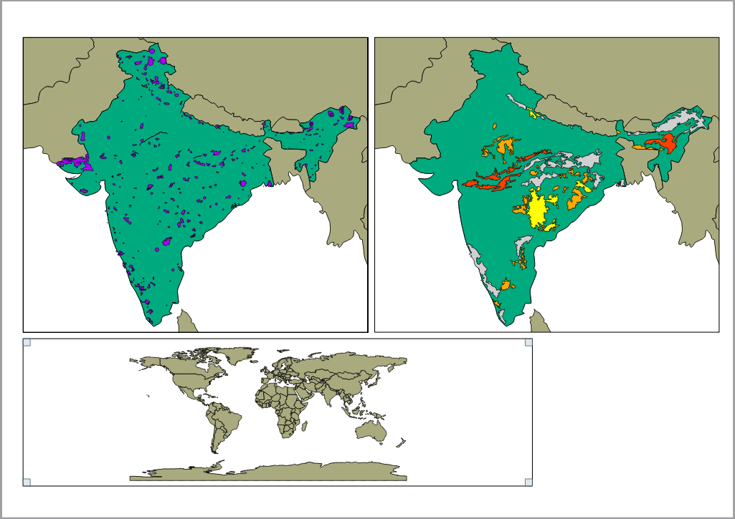

Now that we have all of our maps in position we need to add a title.

- From the top menu select Layout > Add label click somewhere along the top of the map. The Item Properties box should become visible and the words QGIS added to the map display
- In Item Properties change the words to Tiger Conservation
- Click on Font and change the Font Style to Bold and the Size to 28 (you might need to drag out the box in the map display to fit the text)
- Under Vertical Alignment select the radio button named Middle (leave the Horizontal Alignment button on Left)
- Check the checkbox next to Frame

You should save your work regularly as you go through this practical. Do save what you have done in the Print Composer window, either click the Save button in the top-left corner or click Composer > Save Project. Let’s add some more details:

- Under Item Properties find the Background property and change the colour to a light grey.
- Drag the grey frame to align with the other maps in the figure.

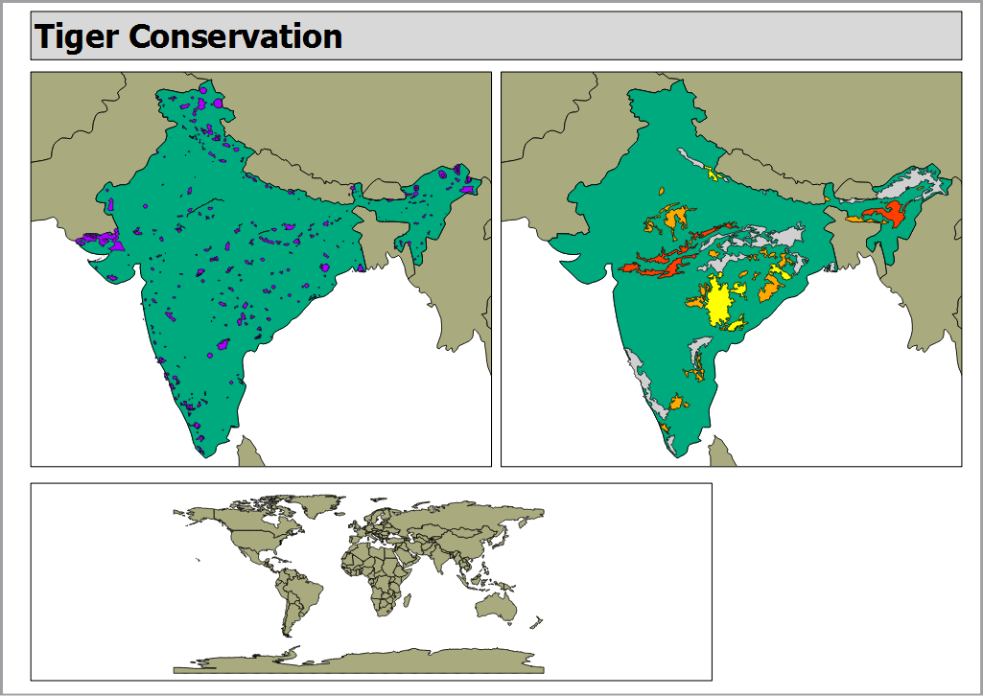

We’ll now add a small subtitle to the Tiger Conservation title.

- Add another label in the same way but change the text to Size 18 and Font Style to Italic
- Change the words to read: an assessment of critical habitat in India and expand the box so that the words are all visible
- Finally, position the subtitle next to the title.

We now need to add legends, scalebars and a north arrow to our maps so that the user has a sense of scale and so that they can easily distinguish what each of the colours mean.

To add a legend:

- Make sure that you have the Select/Move item tool selected and click on the top left map
- With the top left map selected go to Layout > Add Legend and click on the map and a legend will appear
- Under Item Properties go to Main Properties and remove the title (it’s not necessary to have a title for the legend, or key, in this map but it might be in other situations)
- The legend includes all the items in the QGIS project window. To remove some of the unnecessary items go to Item Properties > Legend items and untick Auto update. From this you can select items and remove Tiger conservation units from the legend
- Make sure that you have the Select/Move item tool selected and position the legend in the bottom right of the Wildlife reserves map
- Check the checkbox next to Frame to add a border, change the thickness to 0.10
- Repeat this process to add another legend containing all of the layers that are visible in the top right (Tiger conservation units) map. You can change the order of items that appear in the legend under Item Properties > Legend items and by using the up 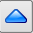 and down  arrows. Feel free to play around with the various legend settings to create custom legends.

To add a north arrow:

- Click on Layout > Add Arrow from the top menu bar and draw the arrow in a suitable position on the map (the top right in each of the two top maps would be a appropriate)

To add a scalebar:

- Select the Select/Move item tool and click on the top left map
- Click on Layout > Add Scalebar and click on the map. A scalebar will now be added to the map (its style will depend upon the last settings that you used so may differ slightly here). Under Item Properties > Scalebar make sure that the correct corresponding Map is selected from the dropdown box (in my case the top left map is Map 0 so this should be selected here). Change this value to match the name of your top left (wildlife reserves) map and change the Style to Single Box
- Change Unit Label to Km and map units per bar unit to 0.01 (as our data is in the WGS 84 datum which is decimal degrees – one decimal degree is roughly 111.111 metres which equates to 0.01 map units)
- Make sure 0 Left segments and 1 Right segments is selected
- Change Segment size to 5
- Feel free to change any of the other settings such as Font or Colour before moving on
- Place the scalebar in a suitable place on the map
- Repeat the process for the top right (Tiger conservation units) map using the same values.

Our map is almost finished. Annoyingly, we have a large white space in the bottom right hand corner of the map. What can we fill this with? Conveniently, we have an image of a Tiger in the data files!

- To add the image of the Tiger, go to Layout >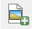 Add Image and draw a box on the map
- Under Item Properties > Main properties click on the button next to Path and navigate to the prac2 folder. Select the Tigerpic.jpg image and position it in the bottom right hand corner of the map
- Finally, under General properties uncheck the checkbox next to Show Frame. Don’t worry if the white border of the image goes over the full extent of the page, it will not show once exported

To export a copy of your map

- Go to Composer > Export as PDF, choose a location and a filename to save your map.

3. Mapping population change in India (optional exercise)

Now you have seen the process of creating a publication quality map, let’s make it a bit more challenging and get you to make a different sort of map, using the skills you have learnt today. Your task is to make a map of population and/or population change in India. It should be a map of publishable quality, like the one we created for the Tiger Conservation areas. How you lay the map out, and whether you show population or population change, or both, is up to you.

These are the data you will need:
- The Indian state (level 1) spatial boundaries, which can be downloaded from www.gadm.org. Make sure you download the shapefile version.
- The Indian population data from the 2011 and 2001 census. You can download this from http://censusindia.gov.in, but you need to register so I have downloaded this data for you (india_2001.xlsx and india_2011.xlsx).

I have done some of the data processing for the Indian Census data (included in the practical zip file), but you will need to do some as well. You will need to join the census data to the boundaries, calculate the population change, and then map the data. Remember to reference the data sources. Good luck!


Written and tested using QGIS 2.6 on 13/11/2014 by Nick Bearman.

This work is licensed under the Creative Commons Attribution-ShareAlike 4.0 International License. To view a copy of this license, visit http://creativecommons.org/licenses/by-sa/4.0/deed.en.



